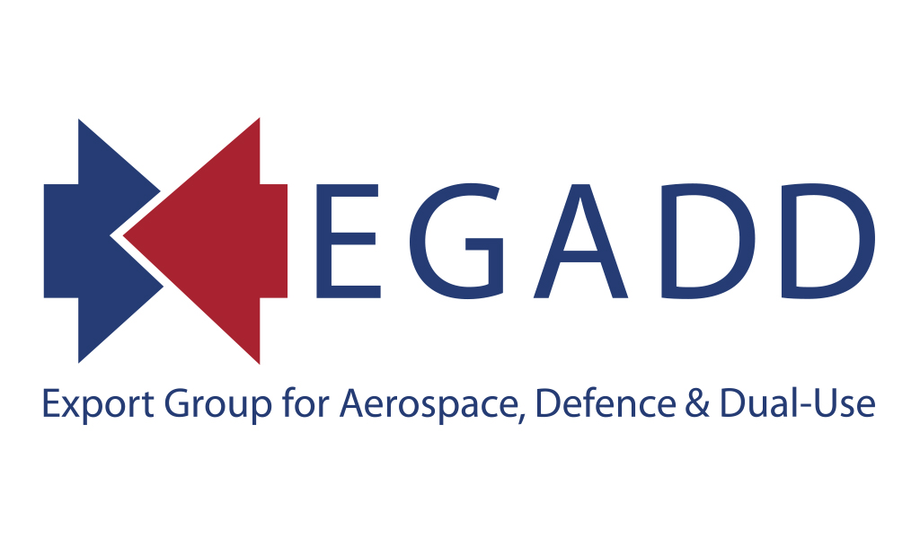
Operating under the joint auspices of:



www.egad.org.uk

EXPORT GROUP FOR AEROSPACE, DEFENCE & DUAL-USE
TERMS OF REFERENCE

AIMS AND OBJECTIVES
Formed in September 2004, through the merging of the Defence Manufacturers Association’s British Defence Manufacturers Export Licensing Group (BDMELG) and the Society of British Aerospace Companies’ Export Controls Working Group, EGADD now operates under the joint auspices of ADS, British Marine, BNEA, CBI, SMI and TechUK.

EGADD’s purpose shall be as indicated in Appendix 1.

MEMBERSHIP
Membership of any of the above named Associations is not a pre-requisite for Membership of EGADD. However, membership of these organisations entitles a company to free Membership of EGADD, whilst non-Members of these organisations will be required to pay an annual subscription of £220 + £44.00 VAT @ 20% = £264.00 per annum.
Membership shall be limited to any companies and their suppliers that have been, are or will be active in exporting controlled products, technology or services, or in activities caught by the UK’s Trade or Export Control Regulations, or persons or companies who provide related services to such exporters.
In addition, at the discretion and with the agreement of the Chairman and other Members of the Executive Committee, representatives of relevant Government Departments, subject matter advisers and experts, and other Trade Associations, in related industries, may be invited to attend meetings of the group of and be kept informed of its activities.

FINANCE
EGADD is a not-for-profit-making, self-financing group. The running costs for each Meeting will be shared equally amongst the companies attending each Meeting. As a normal rule, any expenses incurred on behalf of the Executive Committee will be borne by the company of the Member concerned.

MEETINGS
EGADD as a whole shall meet annually as a minimum, as well as organising other events of benefit to the Members (this includes regional workshops, FCO Briefings etc). Government Departments and other specialists will be invited to be represented at an appropriate level as guests and speakers to address issues of current interest and concern. The fees for attendance of these Meetings shall be limited to an equal share amongst attendees of the costs of any Meetings.
THE EXECUTIVE COMMITTEE
EGADD is run by an Executive Committee (a minimum of 8 persons, and a maximum of 18, with a quorum of 6 to validate an EC meeting, plus any Honorary Members), which is intended to provide a broad spectrum of Industrial representation. The initial Executive Committee was formed, at EGADD’s inception by the combination of the Executive Committee of the BDMELG and the Members of the SBAC’s Export Controls Working Group.
In 2009 the Executive Committee decided to change its nature and composition, to enable the Group to be seen to operate in a more democratic way, and to allow and facilitate the inflow of fresh Members to be achieved. The future purpose of EGADD shall be to raise awareness of the profession of export control compliance.
The Executive Committee shall be elected by democratic vote of the EGADD Membership at the annual Main Meetings of the EGADD from 2009 onwards, on a rolling basis with a third of the seats on the EC being made open for election, and with each individual Member having one vote. Votes may be cast at the Main Meeting or by nominated proxy.
Executive Committee Members will normally serve on the Committee for three years, unless they retire or miss three consecutive meetings, in which case they will be open to being automatically retired, by resolution of the EC Members. At the end of their three-year period, Executive Committee Members will be eligible to stand for re-election for a further term.
The Secretary will maintain a list of candidates to stand for election to the Executive Committee. All candidates must be capable, willing and able to contribute to the group’s activities. Election to the EC is personal, and based on that person’s own expertise. If an EC Member changes his/her company, then their continued presence on the EC will be subject to review by their fellow EC Members.
The Committee will have the authority to co-opt Members as necessary.
The Executive Committee will appoint a Chairperson and up to three Vice-Chairpersons. The Secretary will be provided by ADS, as an ex-officio Member of the EC. The names and company addresses of these appointees are to be notified to all Members.
The Committee will have the power to appoint past Chairpersons and Vice-Chairpersons to honorary non-voting posts, and for specified purposes and responsibilities, if deemed appropriate, on their retirement from these positions, in exceptional circumstances.
Minutes shall be kept of all Executive Meetings and shall be circulated to all Members of the Committee. The Minutes shall record: all appointments of officers; the names of all attendees at each meeting; a record of all recommendations, resolutions and proceedings.

ORGANISATION
EGADD, although an independent body, is administered by ADS, who handle all Membership matters, organise Group Meetings and disseminate information as directed by the Executive Committee.

Applications for Membership should be addressed to:-

The Membership Secretary (EGADD)
c/o ADS
“ShowCentre”
ETPS Road
Farnborough
Hampshire GU14 6FD
Tel: +44 (0) 20 7091 7822
Fax: +44 (0) 20 7091 4545
E-Mail: brinley.salzmann@adsgroup.org.uk

and can specify EGAD Membership only. Membership of ADS, British Marine, BNEA, CBI, SMI and TechUK is not a prerequisite.
APPENDIX 1

PURPOSE OF THE EXPORT GROUP FOR AEROSPACE, DEFENCE & DUAL-USE

- To be the primary forum for Government Departments to demonstrate to British Industry the validity and necessity of existing and future procedures and regulations and to make the former aware of the latter’s resulting difficulties.
- To ensure that the Government departments responsible for formulating policy pay greater attention to the unique needs, technical issues, problems and views of the Aerospace, Defence and Security Industries.
- To be the primary conduit through which ECO will consult with UK Industry on proposed improvements to the OGEL system.
- To be the primary conduit through which UK MoD will consult with UK Industry on proposed improvements to the UK MoD Form 680 procedure.
- To provide a forum for discussion in which aerospace, defence and security companies may exchange ideas and raise matters of common interest in the export control sphere with representatives of the relevant UK and overseas Government Departments, their agencies and other relevant bodies and organisations.
- To promote awareness of the UK’s export control system amongst companies so that a maximum degree of knowledge and confidence in the regulations can be achieved.
- To disseminate amongst its Members reliable and up-to-date information concerning export control requirements.
- To provide assistance to its Members engaged in meeting UK export control regulations and to involve itself, where appropriate, in the resolving of detailed problems between individual Member companies and Government departments.
- To complement and co-ordinate with the activities of other Trade Associations on export licensing matters on behalf of the UK Aerospace, Defence and Security Industries and formalise a closer relationship between Government and Industry.
- To provide input to ADS on issues to be raised and discussed by the Government/Industry Export Control Advisory Committee.
- To liaise with and undertake work on behalf of the Defence Industries Council (DIC) and submit briefing documents on major export control related issues to DIC through the DG of ADS.
- To assess the impact of Export Licensing Regulatory Regimes within USA and EU as they affect UK companies.
- To collaborate with overseas Aerospace, Defence & Security Trade Associations on export control issues where doing so may have benefits for UK Industry.
- Any other purpose or activity deemed by the Executive Committee as being beneficial to the Membership.

